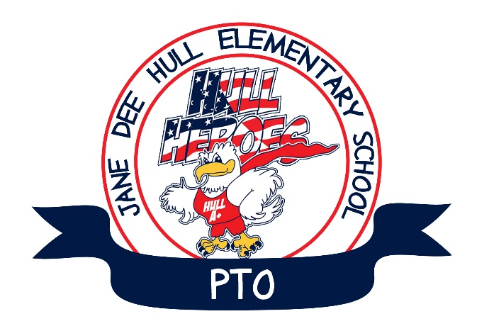
Agenda
Hull Elementary PTO
August 1, 2017
Hull Library

1. Call to Order

2. Welcome and Introductions

3. Approval of May Minutes

4. President’s Report
Scott Koehler
a. Meet the Parents / Curriculum Night
- Reserved Parking Space Drawing
- $50 raffle drawings
b. Upcoming Events
- FlipSide – Firsts day on Parent/Teacher conferences. Wednesday, August 30th.
- Check-A-Thon Will run through the month of September
- Mother/Son game night Friday, September 15th
- Papa John’s Restaurant Night (Take-out or Delivery) Friday, September 22nd
- Other restaurant nights coming soon! Need feedback for dates.
  - Peter Piper Pizza – Pizza with the principal
  - Sonic
  - Rita’s Burritos
  - Zuppas
  - Toscany’s
  - Slim Chickens
  - Others

c. CSB Grant opportunities

d. Box Tops for Education August Rewards Program

e. Teacher Favorites Form

5. Treasurer's Report
Julie Vargo
2016-2017 P&L
Scott Koehler
2017-2018 Budget
Teacher Funds
Grade Level Funds
Reallocation of Funds

6. Principal's Report
Cheryl Bromich

7. Committee Reports
Plea for volunteers

8. Open Discussion

