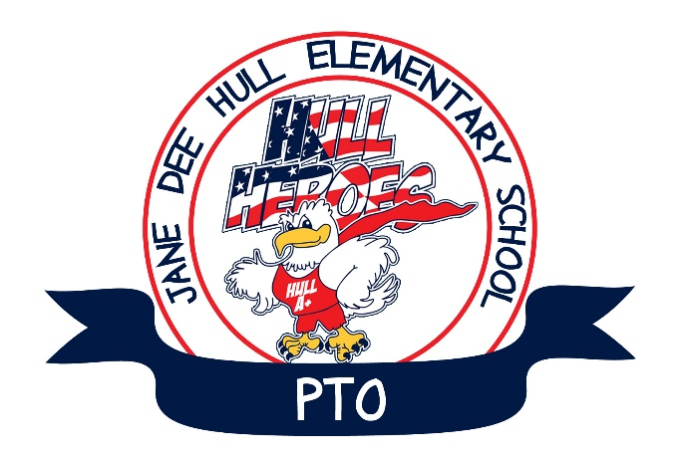
Agenda
PTO Meeting
September 5, 2017
Hull Elementary Media Center

1. Call to Order

2 Welcome and Introductions

3. CUSD Override
Jennifer Pawlik Co-Chair

4. President’s Report
Scott Koehler
- Past Events
- Flipside Spirit Night
- Current and Upcoming Events
- CASH for C.O.W.s – Through the end of September
- Mother / Son Game Night – September 15th
- Café Zuppas Restaurant Night – September 12th
- Papa John’s Restaurant Night – September 22nd
- CSB Grant Opportunities
- APS / Diamondbacks STEM Grant Opportunities

4. Treasurer’s Report
Julie Vargo

5. Principal’s Report

6. Open Discussion

